**How to Build an Order / Message Queue System on AWS using SQS and Lambda functions**

**Order Placement:** When a customer places an order on the KFC shop application, the application backend receives the order details, such as the customer's name, address, and the items they want to order.

**Queueing the Order:** The backend of the application uses AWS SQS to queue the order. SQS allows for reliable and scalable message queuing, ensuring that orders are processed in a decoupled manner.

**Processing the Order:** The backend worker or processing component, which could be running on AWS EC2 instances or AWS Lambda functions, continuously polls the SQS queue to retrieve new orders. Once an order is retrieved, the worker processes it, which involves tasks like preparing the food, updating the order status, and notifying the customer.

if KFC Shop 2 closes, KFC Shop 1 can continue to operate and process orders. The backend worker responsible for KFC Shop 1 will ignore orders intended for KFC Shop 2 and focus on processing its own orders.

1. Create a Message Queue system with Amazon SQS

Navigate to AWS SQS and create a SQS

I just keep everything as default, and I enabled the encryption and created a SQS.

1. Create an IAM role for Lambda function

Attach SQS Full Access and CloudWatchLogs Full Access permission to this role

Name it and create a role for lambda.

1. Create a Lambda function for backend application

Attach an IAM role (which is created in step-2) and increase the timeout as 1 minute in Lambda timeout.

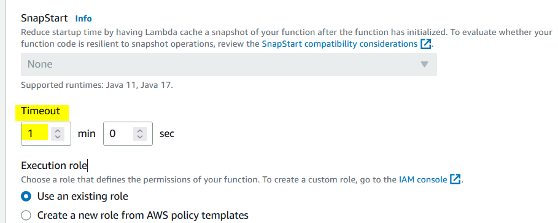

1. Create a two lambda for two kfc shops

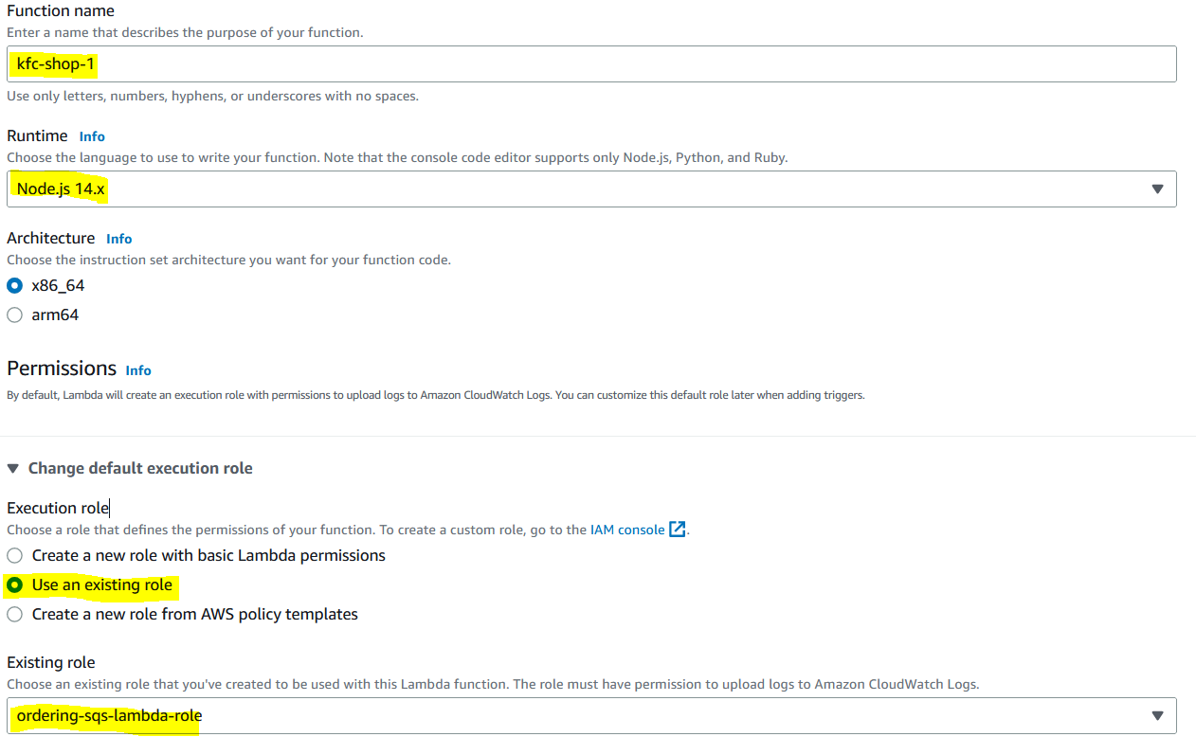

Change the default timeout to 1 minute and concurrency – reserve concurrency – 1 – save changes.

Create one more lambda for kfc-shop-2 and do all the configuration as mentioned kfc-shop-1

Now we have 3 lambdas as below

1. Add SQS as trigger for both kfc-shop-1 & kfc-shop-2 lambda

And add trigger. Now its look like below

1. To update the code in application-backend-lambda

<https://github.com/kohlidevops/ordering-burgers-kfc-using-sqs-lambda/blob/main/application-backend-lambda.js>

1. To update the code in kfc-shop-1 lambda

<https://github.com/kohlidevops/ordering-burgers-kfc-using-sqs-lambda/blob/main/kfc-shop-1-lambda.js>

1. To update the code in kfc-shop-2 lambda

<https://github.com/kohlidevops/ordering-burgers-kfc-using-sqs-lambda/blob/main/kfc-shop-2-lambda.js>

1. To test the application-backend-lambda code

Save and test the code

1. Queuing system process the order

1. To check the CloudWatch logs for kfc-shop-1 & 2

kfc-shop-1 logs

kfc-shop-2 logs

